Conic

MD. MOHIUDDIN

LECTURER, Comilla university

2020

**Conic**

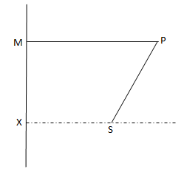**Conic section regarded as locus:** If a point P moves in a plane such a way that the ratio of its distance PS from a fixed point S in the plane to its perpendicular distance PM from a fixed straight line XM in it, is always a constant, then the locus of that point P is called a Conic section or briefly a Conic.

The constant ratio is called the eccentricity of the conic and is generally represented by the letter ‘e’. The fixed point S is called the focus and the fixed straight line XM is called directrix of the conic. The conic is called a Parabola, an Ellipse, and a Hyperbola, and according as the eccentricity 

That is for a Parabola 

for an Ellipse 

for Hyperbola 

The eccentricity is a positive number. If then the conic represents the circle, which is the special case of ellipse.

In generally, a conic section or simply a conic is a [curve](https://en.wikipedia.org/wiki/Curve) obtained as the intersection of the [surface](https://en.wikipedia.org/wiki/Conical_surface) of a [cone](https://en.wikipedia.org/wiki/Cone_(geometry)) with a [plane](https://en.wikipedia.org/wiki/Plane_(mathematics)). If the cutting plane passes through the vertex, the section consists of two straight lines, real coincident or imaginary. If the cutting plane does not pass through the vertex of the cone, the conic belongs to one of the following four types:

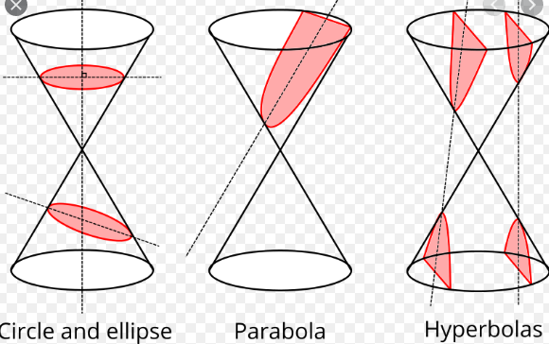

(1). If the cutting plane is parallel to the base, the section is a circle.

(2). If the cutting plane does not parallel to the base and cuts entirely across one nappe of the cone,

the conic is an ellipse.

(3). If the cutting plane is parallel to a rectilinear element of the cone, the conic is a parabola.

(4). If the cutting plane cuts both nappes of the cone, the conic is a hyperbola.

**Circle**

**Circle:** A circle is the locus of a point in a plane which moves so that its distance from a given point is always constant. The given point is called the centre and the distance is the radius of the circle.

Let  be the centre of the circle whose radius is ‘r’ and  be any point on the circle.

Then  or, 



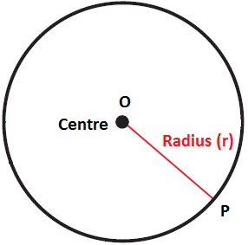which is the required equation of circle.

If the centre of the circle is the origin, then the equation becomes



The equation (1) can be written as



which is therefore of the form



where, and  are constants.

This is the general form of the equation of circle. It can be rearranged as





where , which is radius of the circle. The centre of the circle is at .

If , the radius of the circle is greater than zero and the equation (4) represents a real circle.

If , the radius of the circle is zero and the equation (4) represents a circle of zero radius. This is known as point circle.

If i.e.  is negative. The radius  becomes imaginary. The equation (4) represents an imaginary circle.

**Equation of circle in polar coordinates:** Let the centre S of the circle is at  and R is the radius of the circle. Let P be any point  on the circle. Then the angle  and from the 

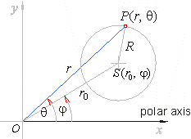





The equation of the circle in terms of polar co-ordinates is



where  is the centre of the circle.

If the pole lies on the circle, then . The equation of the circle is



If , the equation of the circle of radius R is



If the centre is the origin (i.e. the pole), the equation of the circle becomes

.

**Question-01:** Find the equation of the circle described on the line joining the points and as diameter.

**Answer:** Let and and  be the three points on a circle. Let AB be its diameter. Since the lines joining AP and BP are perpendicular to each other, so

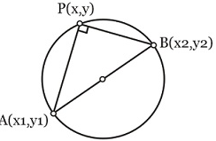 

The slope of the line AP is,



The slope of the line BP is,



Using (2) and (3) in (1), we get





This is the required equation of the circle.

**Question-02:** Find the equation of the tangent at the point to the circle .

**Answer:** The equation of any line through the point is

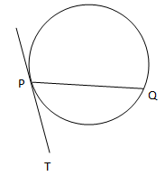

If this line meets the circle again at , then

.

Since and lie on the circle, we have



and .

Subtracting (3) from (4), we get







.

The limiting value of ‘m’ as Q tends to P, that is, as  and  is therefore



Hence, from (1) and (5), the equation of tangent PT at the point is





.

Adding  to both sides,





This is the required equation of the tangent to the circle.

**Question-03:** Find the equation of the normal at the point to the circle .

**Answer:** The equation of the normal at is



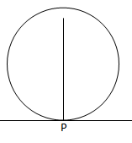Now, the equation of the tangent to the circle at the point is





.

Therefore, the slope of the tangent is



Since the normal is perpendicular to the tangent, we get





Using the value of m in (1), we get



.

This is the required equation of the normal to the circle.

**NOTE:** 1. The general equation of all circles passing through the two points and is



where, A is constant and it will be calculated if the circles passes through the two point .

2. The equation of a tangent at to the circle is .

3. The equation of the normal at to the circle is .

**Question-04:** Show that the straight lines are always tangents to the circle .

Answer: Let the equations of straight line and circle are



and 

Suppose the line (1) meets the circle (2). So from (1) and (2), we have







If the line (1) always touches the circle (2) then x has equal roots in (3). So











which is, therefore, the condition of tangency of the line (1) to the circle (2).

Put the values of c in (1), then the straight lines are always tangents to the circle  whatever be the value of m. **(Showed)**

**System of circles:** A set of circles is said to be a system of circles if it contains at least two circles. Let two circles are S = 0 and S′ = 0, these circles are said to touch each other if they have a unique point P in common. The common point P is called point of contact of the circles S = 0 and S′ = 0.

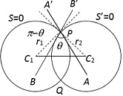**Angle of intersection of two circles:** The angle of intersection of two curves is measured by the angle between the tangents to the curves at a point of their intersection. Since in the case of a circle, the radius to the point of contact of tangent is perpendicular to the tangent, the angle between the two tangents to the two circles at a common point equal to the angle between then radii of the circles drawn to the same point.

Hence if  be the angle of intersection of two circles  and  whose radii are  and  respectively and be the distance between their centre’s  and i.e. , then  gives,







This is the required angle of intersection of two circles.

If the equations of two circles are



and 

where, ,  and , then from (1), we have



.

**Case-01:** If , the two circles touch each other internally and from (4), we have .

**Case-02:** If , the two circles touch each other externally and from (4), we have .**Case-03:** If , the two circles said to be orthogonal when the tangents at their points of intersection

are right angle and from (4), we have .

**Radial axis:** The radial axis of two circles is the locus of a point which moves so that the lengths of tangents drawn from it to the two circles are equal. Let the equations of two circles are,



and 

Let be the point from which the lengths of the two tangents to (1) and (2) are equal, then





Hence the locus of the point  is a straight line i.e. the radial axis of the two circles is,



which is a straight line.

**Problem-01:** Find the equation of the circle described on the line joining the points (-3,7) and (2,-5) as diameter.

**Answer:** The equation of the circle described on the line joining the points (-3,7) and (2,-5) as diameter is





.

**Problem-02:** Find the equation of the circle which passes through the points (2,0) and (-2,0) and (0,3).

**Answer:** Let the equation of the circle be



Since (1) passes through the points (2,0) and (-2,0) and (0,3), so





and





and





Solving (2), (3) and (4), we get

.

Substituting these values in (1), we have

.

**Problem-03:** Find the equation of the circle which passes through the points (-3,2), (1,7) and (5,-3).

**Answer:** The general equation of the circles passing through the first two points (-3,2) and (1,7) is,



Since (1) passes through the third point (5,-3), so





Putting the value of A in (1), we get



.

**Problem-04:** Find the equation of the circle which passes through the points (3,5), (5,-3) and has its centre lies on the straight line.

**Answer:** Let the equation of the circle be,



Since (1) passes through the points (3, 5) and (5, -3), so we have



and 

Also since the centre (h, k) of (1) lies on the line , so we have



Now subtracting (2) from (3), we get



.

Putting the value of h in (4), we get



From (5), we have



From (2), we get



The equation (1) gives,



This is the required equation of the circle.

**Problem-05:** Find the equation of the circle circumscribing the triangle formed by the lines ,

 and . 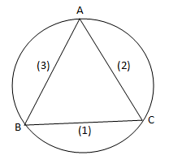

**Answer:** The given lines are,





and 

By solving (2) and (3), we get the vertex A(2, 3) of the triangle.

By solving (3) and (1), we get the vertex B(1, 2) of the triangle.

By solving (1) and (2), we get the vertex C(3, 1) of the triangle.

Let the equation of the circle be



Since the circle (4) circumscribing the triangle ABC, so the circle passes through the vertices A, B, C. So that we have







Subtracting (6) from (5), we get



Subtracting (6) from (7), we get



By solving (8) and (9), we get

.

Putting the values of g and f in (5), we get

.

From equation (4), we get



This is the required equation of the circle.

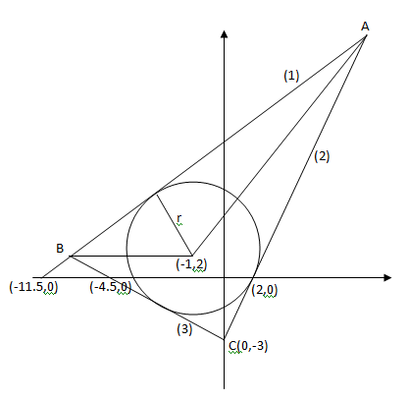**Problem-06:** Find the equation of the circle inscribed in the triangle formed by the lines ,

 and .

**Answer:** The given lines are,





and 

The centre of the required circle lies at the point of intersection of the bisectors of the interior angles of the triangle formed by the lines (1), (2) and (3).

The bisector of the interior angle between the lines (1) and (2) is,

 ;[Since the constant terms of the equ.s are opposite sign.]



The bisector of the interior angle between the lines (1) and (3) is,

 ;[Since the constant terms of the equ.s are same sign.]



Putting the value of y in (4), we get



Hence the required circle is



.

**Problem-07:** Find the equation of the tangents to the circle , which are parallel to

the straight line 

**Answer:** The given equation of the circle is,





Whose centre is (2, -3) and the radius is 4.

The given line is



Since the tangents to the given circle (1) are parallel to the straight line (2), so the equations of the tangents are,



The length of perpendicular from the centre (2, -3) to the tangents (3) must be equal to the radius 4.

i.e. `





Putting the value of k in (3), we get

when k=2,



when k=-38,

.

These are the required tangents.

**Problem-08:** Find the equation of the circle which passes through the point (1, 2) and the point of intersection of circles  and .

**Answer:** The given circles are,



and



A circle through the intersection of the given circle (1) and (2) has equation of the form,



Since the circle (3) passes through point (1, 2), so we get





Putting the value of  in (3), we get



This is the required circle.

**Problem-09:** Prove that the following circles  and  cut orthogonally.

**Answer:** The given circles are,



and



From (1), we have

.

From (2), we have

.

The circle (1) and (2) will cut orthogonally if



i.e.



.

This is true. Hench the given circles cut orthogonally. (**Proved**)

**Problem-10:** Find the equation of the circle which cuts the circles  and

 orthogonally and passes through the point (1,1).

**Answer:** The given circles are,



and



Let the equation of the required circle is



Since the circle (3) passes through the point (1, 1), so we have

.

Since the circle (3) is orthogonal to the given circles (1) and (2), by the condition of orthogonally we have,



and .

By solving (4), (5) and (6) simultaneously, we get

 .

Putting these values in equation (3), we get



This is the required circle.

**Problem-11:** Find the equation of the circle passing through the points of intersection of the line

 and the circle  and cutting the circle 

orthogonally.

**Answer:** The given line is,



and the circles are,



and .

The equation of the circle through the point of intersection of the line (1) and the circle (2) is given by,





Since the circle (4) cuts orthogonally the circle (3), so by the condition of orthogonally we get





Putting the value of  in (4), we get



This is the required circle.

**Exercise:**

**Problem-01:** Find the equation of the circle which passes through the following points:

(a). (1,3), (2,-1) and (-1,1). .

(b). (-4,-3), (-1,-7) and (0,0). .

**Problem-02:** Determine the centres and radii of the circles , 

and . Also show that their centres are collinear.

**Problem-03:** Find the equation of the circle circumscribing the triangle formed by the lines ,

 and  

**Parabola**

**Parabola:** Parabola is the locus of a point in a plane which moves such that its distance from a fixed point is always equal to its perpendicular distance from a fixed straight line. The fixed point is called the focus and the fixed straight line is called the directrix.

**Standard equation of a parabola:** Let S be the focus, ZM the directrix, and P the moving point. Draw SZ perpendicular from S on the directrix. Then by definition, SZ is the axis of the parabola. Now the middle point of SZ, say O is the vertex of the parabola.

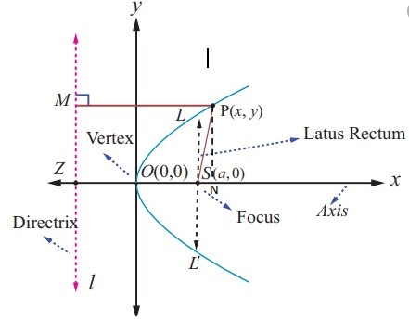

. Take O as the origin, the x-axis along OS, and the y-axis along the perpendicular to OS at O. Let , so that . Let (x, y) be the co-ordinates of P in any position. Then by the definition of the parabola,











.

This is the required equation of the parabola.

The double ordinate  passing through the focus S called the latus rectum and .

NOTE: If the equation of the parabola is , then

1. Coordinates of the vertex are .
2. Coordinates of the focus are .
3. Equation of the directrix is .
4. Equation of the axis .
5. Equation of tangent at the vertex, .
6. Length of the latus rectum is .

**Standard equation of an Ellipse:** Let S be the focus and DZ be the directrix. SZ is drawn perpendicular to the directrix and ZS and ZD are taken as the axes of *x* and *y*.

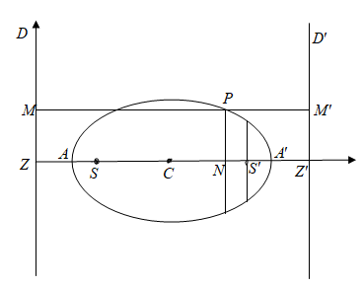

Let the coordinates of S be  so that . Let P be any point on the ellipse whose coordinates are  and PM is drawn perpendicular to the directrix. Then from definition,

 ; where *e* is the eccentricity and 













Now let us take a point *C* on the *x*-axis, i.e. on such that

.

The coordinates of *C* are then . Now transferring the origin to the point and keeping the direction of the axes unchanged the equation (1) becomes,

 [Substituting  for *x* and  for *y*]

Let 

Therefore, the equation (2) reduces to





where , which is positive since , and it is evident that . This is the required equation of an ellipse.

NOTE: If the equation of an ellipse is ; where , then

1. Coordinates of the centre .
2. Coordinates of the foci .
3. Coordinates of the vertices .
4. Equation of the major axis .
5. Equation of the minor axis .
6. Equation of the directrices .
7. Equation of the latus rectum .
8. Length of the latus rectum .
9. Length of the major axis .
10. Length of the minor axis .
11. Eccentricity .
12. If , that is, if the major axis is equal the minor axis, then the eccentricity  and the two foci coincide with the centre of the ellipse. The equation of the ellipse becomes,



which is a circle. Thus a circle is an ellipse with zero eccentricity.

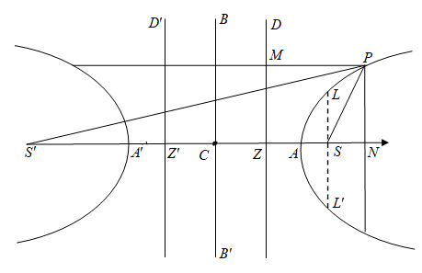**Standard equation of a Hyperbola:** Let S be the focus and DZ be the directrix. SZ is drawn perpendicular to the directrix and ZS and ZD are taken as the axes of *x* and *y*.

Let the coordinates of S be  so that . Let P be any point on the hyperbola whose coordinates are  and PM is drawn perpendicular to the directrix. Then from definition,

 ; where *e* is the eccentricity and 













Now let us take a point *C* on the *x*-axis, i.e. on such that

.

The coordinates of *C* are then . Now transferring the origin to the point and keeping the direction of the axes unchanged the equation (1) becomes,

 [Substituting  for *x* and  for *y*]

Let 

Therefore, the equation (2) reduces to





where , which is positive since . This is the required equation of a hyperbola.

NOTE: If the equation of a hyperbola is ; where *x*-axis is transverse axis, then

1. Coordinates of the centre .
2. Coordinates of the foci .
3. Coordinates of the vertices .
4. Equation of the transverse axis .
5. Equation of the conjugate axis .
6. Equation of the directrices .
7. Equation of the latus rectum .
8. Length of the latus rectum .
9. Length of the transverse axis .
10. Length of the conjugate axis .
11. Eccentricity .

Problem-01: